**CS4310 Project**

December 1, 2014

**School District Network**

**Team Red Bull**

Danny Cruz

Matthew Dawson

Santiago Demaree

Dustin Travis Downing

Anthony Prejean

Michael Lee Van Cleave

**Table of Contents**

|  |  |
| --- | --- |
| **Section** | **Page** |
| Scenario | 3 |
| Project Requirements | 4 |
| Background Investigation and Information | 5 |
| Network Requirements and Design | 8 |
| Network Equipment and Services | 12 |
| Network Performance | 17 |
| Sources | 20 |

**Scenario**

*Provided by instructor*

“Choose an organization (bank, school, or hospital). This could be an imaginary organization. I would expect the organization to have multiple locations, multiple service needs, multiple computing devices, multiple network devices, and other electronic/IT devices in use or planned in the future.”

**Project Requirements**

*Provided by instructor*

**Task 1**

“Investigate and document all locations, computing devices, number of end users, any special IT equipment needs of the organization, etc. that will be accounted for in your network.”

**Task 2**

“Collect all information (such as specification, etc. from Task 1 that will help you identify the parameters needed to be supported by the network you will design. Your design must include all three mediums of communication.”

**Task 3**

“Plan and design the network to connect all locations, and all equipment at each location to provide full connectivity.”

**Task 4**

“Ensure that your design meets specific network parameters such as performance, link data rates, redundancy, diversity, etc. Keep cost in mind during the design process.”

**Task 5**

“Document the four (4) tasks above and present as your network plan. Your report must also show the network topology (map).”

**Background Investigation and Information**

**Locations**

For the purposes of this project, we created a fictional new school district based on the Leander Independent School District in Leander, Texas. These schools are being built adjacent to the 183A toll road expansion. This will allow our project to take advantage of the ongoing construction to lower the cost of fiber installation.

The new school district will consist of one high school, two middle schools, and six elementary schools. This ratio of schools is in accordance with information obtained from a representative of the Austin Independent School District.

*Map of School District*

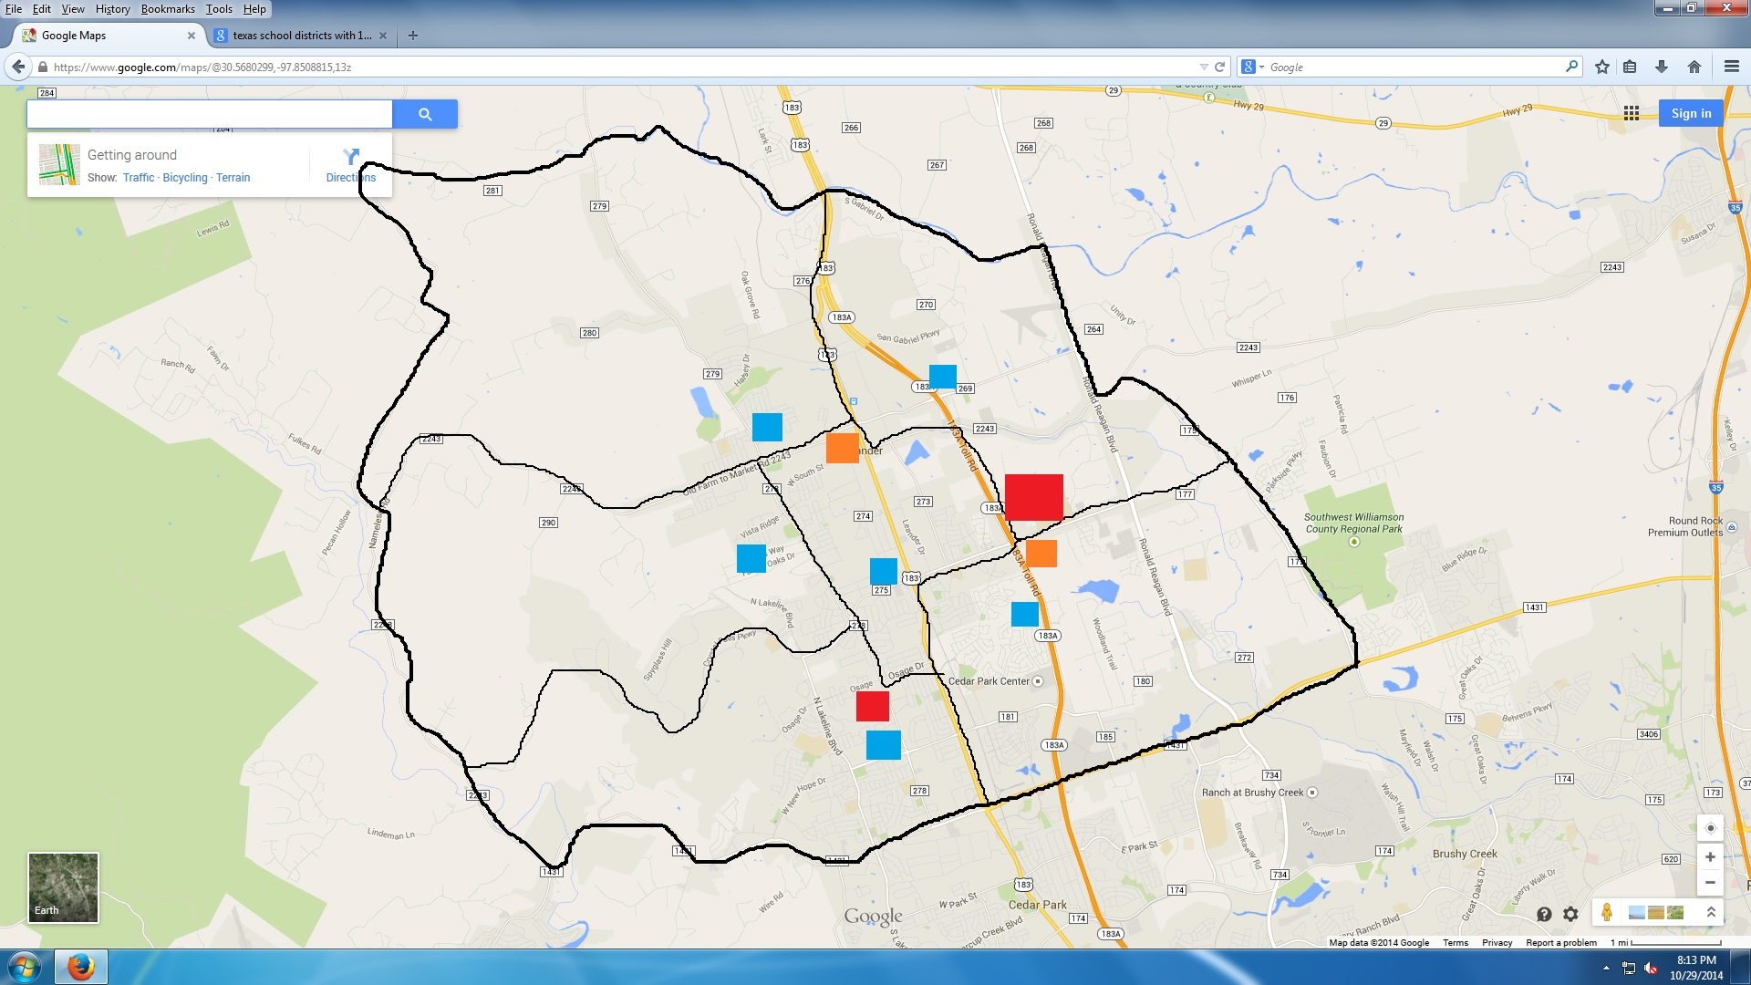

**Number of End Users**

The total number of end users was determined using the National Center for Education Statistics for number of students in each school and the target faculty/administrator per student ratios obtained from an Austin Independent School District representative. This number was used not only to determine the type and quantity of computing devices needed, but also to assess our future capacity for growth.

*Number of End Users*

|  |  |  |  |  |  |
| --- | --- | --- | --- | --- | --- |
| **School** | **Campuses** | **Students** | **Teachers** | **Administrators** | **Total** |
| High School | 1 | 1,000 | 50 | 10 | 1,060 |
| Middle School | 2 | 800 | 40 | 8 | 1,696 |
| Elementary School | 6 | 300 | 15 | 3 | 1,908 |
| Administration Building | 1 | - | - | 32 | 32 |
|  |  |  |  | **District Total** | 4,686 |

**Number of network computing devices**

Although there are 4686 total potential users, we anticipate only a small portion of these on at any given time. With roughly 669 desktops and 80 tablets issued district wide, that is a total of 749 networked computing devices. In the high school and middle school we also have “network bars” that students can hook up to if they choose to bring their own computers. However, these are limited to only 20 plug ins in the High school and 20 in each middle school which if all used puts the district at a total of 809 network computing devices.

**Other network devices**

In addition to networked desktops, laptops, and tablets, we accounted for a number of other network-connected devices. These devices will fulfill security and administrative functions.

Surveillance cameras and keycard access locks will be used to secure the building. Keycard devices require a trivial amount of bandwidth, but storing surveillance footage from all 100 security cameras across the district will require some additional consideration.

Devices such as clocks, cash registers, and public address systems will also be connected to the network. While none of these require a significant amount of bandwidth, the cash register’s connection will have to be secured by the firewall.

**Network Requirements and Design**

**Requirements**

* Minimize annual expenses and total cost of ownership.
* Minimize incoming bandwidth usage.
* Create a redundant network topology.

**How we identified our requirements**

Based on our research, we identified several important factors that would guide our decision-making process. Some of these factors are common to all large networking projects, while others were unique to a school district network.

The first of these factors was cost. Most public schools, even in wealthy school districts are underfunded. In Texas, public school spending per student has been on a decline since 2009, while the number of students enrolled has increased annually since 2002. This made cost-cutting a primary concern.

During construction, however, school districts have access to a much larger amount of funding. Funding large construction projects requires school districts to raise money through municipal bond elections. This makes it easier to purchase and install expensive network infrastructure during new campus construction, rather than adding capacity with funding from annual budgets.

Due to these unique restrictions, we chose to minimize our network’s total cost of ownership by increasing our initial acquisition costs and decreasing our annual operating costs. This means creating a robust network with plenty of excess capacity, so that future expansion will not be limited by uncertain annual budgets. We also chose to minimize our IT staff by using cloud services and managed hardware when possible.

As another cost-saving measure, we also chose to design the network to minimize bandwidth usage. This meant finding creative ways of dealing with high-bandwidth activities, such as streaming video.

Redundancy and reliability were also important requirements. The district is being connected by its own fiber installation, not commercial fiber, so we had to ensure that one broken connection would not disable the entire network. This necessitated careful selection of our network topology.

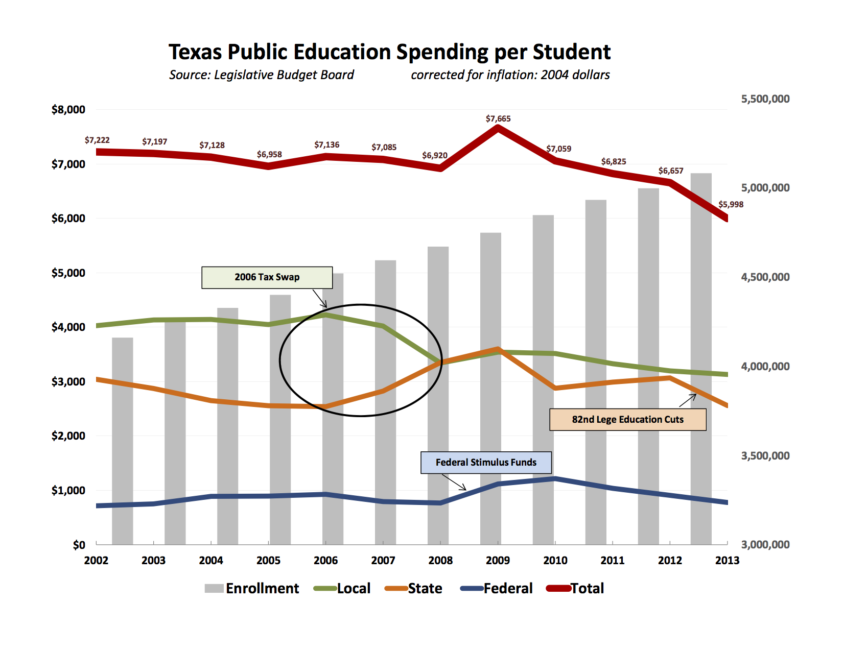

Source: http://genefortexas.com/docs/LBB_PublicEd.pdf

**Network Design**

The network was designed to use all three mediums of communication, with the schools having access over wifi and wired connections and the schools being connected together over fiber optic. The schools are networked using a hybrid ring/star topology. This provided the redundancy necessary to create a reliable network connection without any extraneous connections. In addition to its redundancy, this design is highly cost-effective. This can be seen in the maps and distance measurements below.

*Fiber optic network map*

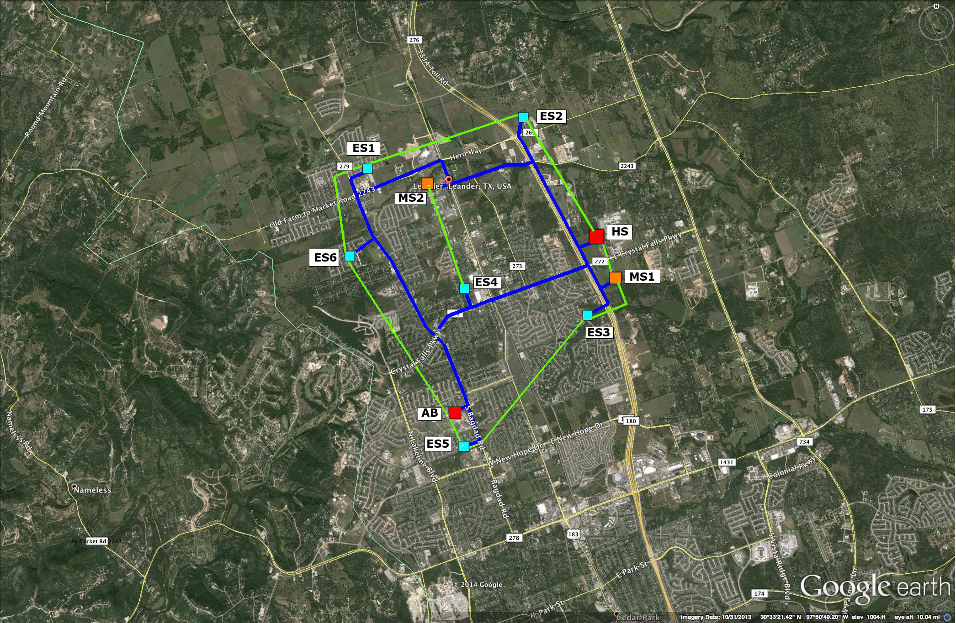

Blue lines are part of the primary fiber optic network.

Green lines are part of an optional future expansion plan.

*Distances between schools*

|  |  |  |
| --- | --- | --- |
| **Start** | **End** | **Distance** |
| High School | Elementary School 2 | 2.3 mi |
| Elementary School 2 | Middle School 2 | 1.8 mi |
| Middle School 2 | Elementary School 1 | 1.2 mi |
| Elementary School 1 | Elementary School 6 | 0.9 mi |
| Elementary School 6 | Administration Building | 2.4 mi |
| Administration Building | Elementary School 4 | 1.4 mi |
| Elementary School 4 | Middle School 1 | 2.5 mi |
| Middle School 1 | High School | 0.8 mi |
|  | **Total** | **13.3 mi** |

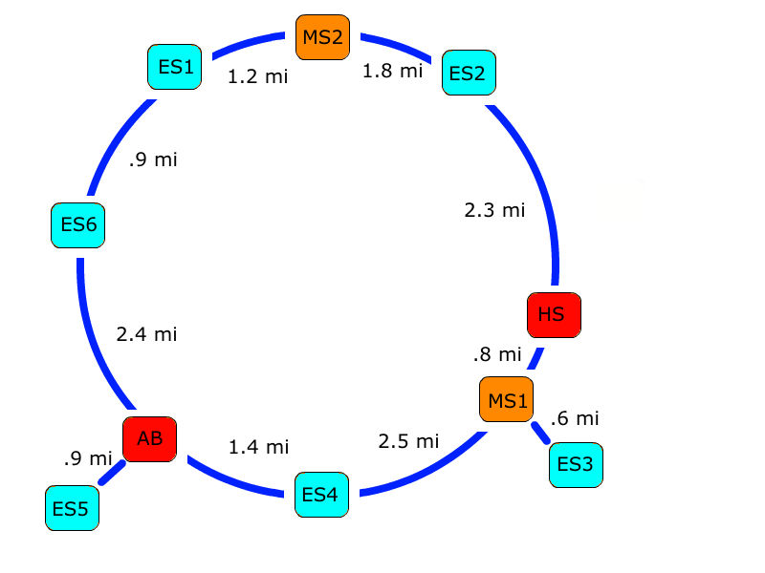

**Network Equipment and Services**

**Network Equipment**

Our choice of network hardware was based on a combination of low unit cost and brand familiarity. Cost considerations are consistent with our network requirements. Brand familiarity is a result of several group members having previously worked with the hardware, software, or services in a professional capacity.

*Network Hardware Cost*

|  |  |  |
| --- | --- | --- |
| **Item** | **Quantity** | **Cost** |
| **Fiber Installation** | **-** | **$39,900 total** |
| Single Mode 9/125 OS2 fiber | 13.3 miles | $3,000 / mile |
| **Network switches** | **-** | **$38,000 total** |
| Juniper EX4500 | 2 | $7,500 each |
| Juniper EX3200 | 8 | $1,500 each |
| Juniper EX2200 | 22 | $500 each |
| NetGear RS108 | 9 | $40 each |
| **Servers and storage** | **-** | **$9,600 total** |
| Dell PowerEdge R420 | 5 | $1000 each |
| Dell PowerVault MD1220 | 1 | $4000 each |
| StarTech 25U cabinet rack | 2 | $300 each |
| Cisco Meraki MX600 | 1 | $0 (renting) |

**Equipment Distribution**

The equipment listed above will be distributed as follows:

* High School
  + 1 Dell PowerEdge R420 (for local software storage)
  + 1 Juniper EX4500 switch (for the access port)
  + 4 Juniper EX2200 switches
    - 1 for each computer lab (3 computer labs total)
    - 1 for the library
  + 5 NetGear FS108 wireless switches (for the library)
* Middle Schools
  + 1 Juniper EX3200 switch (for the access port)
  + 3 Juniper EX2200 switches
    - 1 for each computer lab (2 computer labs total)
    - 1 for the library
  + 2 NetGear FS108 wireless switches (for the library)
* Elementary Schools
  + 1 Juniper EX3200 switch (for the access port)
  + 2 Juniper EX2200 switches
    - 1 for the computer lab
    - 1 for the library
* Administration Building
  + 1 Juniper EX4500 switch (for the access port)
  + 1 Cisco Meraki MX600 (for the firewall)
  + 4 Dell PowerEdge R420
    - 3 for hosting services
    - 1 for video server
  + 1 Dell PowerVault MD1220 (for student and employee records)

*School Network Diagram*

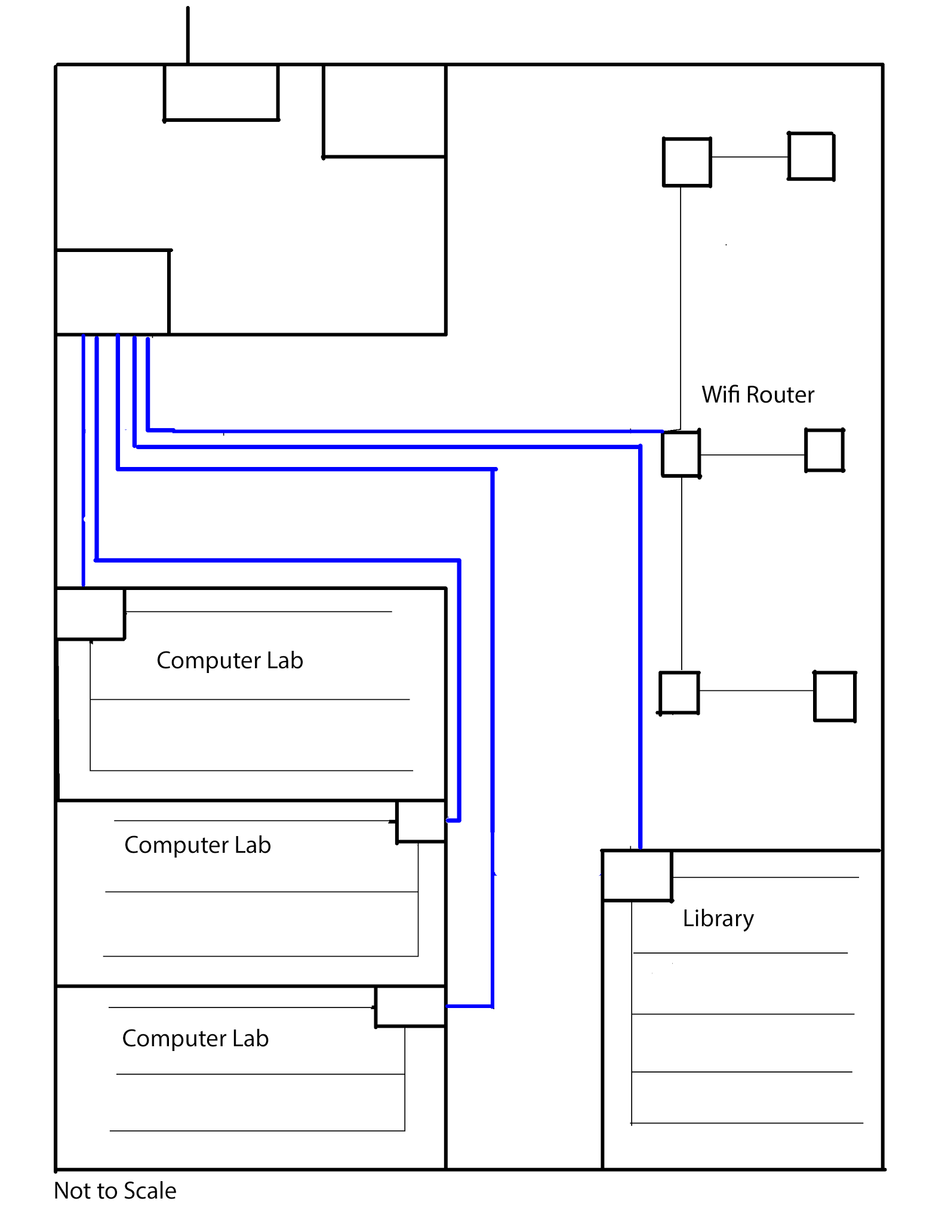

*Networked Devices*

|  |  |  |
| --- | --- | --- |
| **Item** | **Quantity** | **Price** |
| HP desktop, monitor, and keyboard | 351 | $500 each |
| Brother MFC-9130CW printer | 16 | $400 each |
| Lorex surveillance camera | 100 | $32.50 each |
| HP EliteBook Laptops | 22 | $2000 each |
| iPads | 26 | $500 each |
|  | **Total** | **$242,150** |

**Network Services**

In an effort to minimize annual costs, IT staff and recurring expenses have been limited to the essentials. Based on our research, a permanent IT staff of six people was deemed sufficient for a network of this size. This includes one IT worker for high school, one for the middle schools, two for the elementary schools, one for the admin building, and one IT manager. These workers are stationed in the administration building, but will travel to individual campuses as needed.

Broadband internet access will be provided by Conterra Broadband Services. Conterra is an internet services provider that specializes in providing access to public school districts through the Federal Universal Service E-Rate program. This is a program funded by the United States federal government that subsidizes broadband fees for public school districts. Thanks to this program, we are able to give each building 1 Gbps internet access at a 70% discount.

Other recurring costs include cloud backup services through IBM and a managed firewall through Cisco Meraki. While the cost of a managed firewall may seem expensive, it is far less costly than the salary and benefits of an additional employee to monitor the network’s security.

*Annual Network Operation Cost*

|  |  |
| --- | --- |
| Service | Cost |
| IT staff (salary and benefits for 6 employees) | $432,000 |
| Conterra Broadband Services | $66,697 |
| IBM Cloud (includes web hosting) | $3,828 |
| Firewall support | $16,000 |
| **Total** | **$518,525** |

Network Performance

**Estimated Network Traffic**

Based on our research, our network has significantly more capacity than is needed for projected usage. This was determined by looking at our available infrastructure, estimated traffic, and future needs.

For instance, each campus can use up to 1 Gbps. By our estimate, even the high school (which has the largest bandwidth requirement) will use about half of their available bandwidth on average. On the other end of the spectrum, the elementary school only uses about 15% of its available bandwidth. At first glance, it may seem that this is wasted bandwidth. However, this excess capacity serves an important purpose.

Firstly, the excess capacity may be need in the future to expand the network and the number of end-users. Secondly, usage during peak hours (6:00 AM to 6:00 PM) may spike under certain conditions, such as all computer labs being used simultaneously.

*Estimated Network Usage*

|  |  |
| --- | --- |
| **School** | **Estimated Usage (Moderate)** |
| High School | 454 - 479 Mbps |
| Middle School | 363 - 383 Mbps |
| Elementary School | 136 - 161 Mbps |

*Typical Network Usage Patterns*

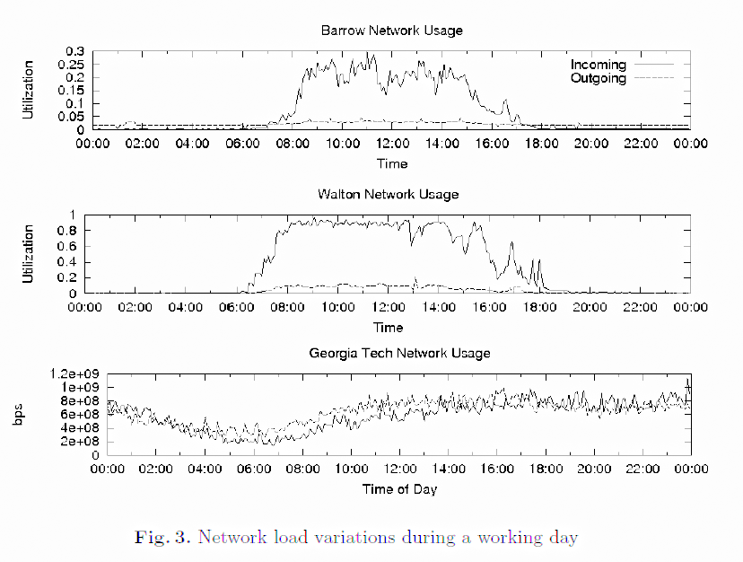

Source: “Internet usage at elementary, middle and high schools: A first look at K-12 traffic from two US Georgia counties”

**Strategies for Minimizing Network Traffic**

Despite our planned excess capacity, it is still prudent to limit network traffic when possible. This will improve network stability and add capacity for future expansion.

Streaming video is one of the most demanding uses of any network. In order to limit the impact of streaming video, we have a designated server for storing and streaming video on the local network. Educational videos can be stored on the server for teachers and students to limit internet traffic during peak hours.

Security cameras pose a similar problem. The district has 100 security cameras, all capable of streaming HD video over the network. This would be an incredibly wasteful use of network resources. Instead, security video streams would be limited in resolution and framerate to conserve traffic. By limiting camera resolution to a reasonable level, the bandwidth needed for all 100 cameras can be reduced to roughly 30 Mbps.

To further reduce traffic during peak hours, all backups, including security camera footage, can be limited to nights and weekends when network traffic is almost non-existent. Also, computer lab schedules can be staggered to prevent all labs being used at once.

**Future Expansion**

By preserving this excess network capacity, we have allowed the network to be expanded in the future if needed. This network expansion may come in the form of new students or schools being added to the district, or by loosening the currently bandwidth restrictions.

Currently, the network’s switches, servers, and firewall are only being used at roughly half of their current capacity. This makes added new users or devices simply a matter of running extra ethernet cable and/or installing extra wireless routers without having to substantially alter the network infrastructure.

The ability to expand our existing network can be used for several purposes. It may be used to increase the number of students per school, or to increase the number of schools in the district. It may also be used to implement a “bring your own device” policy and expand the wireless network, so that students may access the network at any time.

Sources

Bandwidth Calculator

* http://bandwidthpool.com/bandwidth-calculator/

Benefits Wizard

* http://swz.salary.com/MyBenefits/LayoutScripts/Mbfl_Start.aspx

Google Maps

* http://maps.google.com

Student Enrollment Statistics

* http://nces.ed.gov/surveys/sdds/index.aspx

Internet usage at elementary, middle and high schools: A first look at K-12 traffic from two US Georgia counties

* http://www.pam2010.ethz.ch/papers/full-length/16.pdf

Network IP Security Camera System Bandwidth Calculator

* http://www.supercircuits.com/resources/tools/network-ip-security-camera-system-bandwidth-calculator

Texas Public Education Spending per Student

* http://genefortexas.com/docs/LBB_PublicEd.pdf